ECA5802-IOE AND AI DRIVEN SYSTEMS
EXPERIMENT 6(b): SIMUALTION AND PERFORMANCE EVALUATION OF PEOPLE-PROCESS-DATA-THINGS IOE FRAMEWORK USING EDGE AND FOG TO CLOUS PIPELINE

OBJECTIVES:
- To simulate the People-Process-Data-Things (PPDT) framework for IoE applications.
- To evaluate data processing using the Edge, Fog, and Cloud computing pipeline.
- To analyze latency, efficiency, and performance of the IoE framework.

PROGRAM CODE:
import numpy as np
import matplotlib.pyplot as plt
# Simulation parameters
packet_size = 1500 * 8 # 1500 bytes converted to bits
# Data rate in Mbps
data_rate = np.linspace(0.5, 20, 100)
# Standard transmission delay formula
# Delay (ms) = Packet size (bits) / Data rate (bits/s) * 1000
transmission_delay = packet_size / (data_rate * 1e6) * 1000
# Illustrative fixed delay components in milliseconds
# These values are assumptions for simulation, not universal constants
data sources=20
# Edge
edge_propagation = 1* data sources
edge_processing = 2* data sources
edge_queueing = 0.5* data sources
# Fog
fog_propagation = 5* data sources
fog_processing = 4* data sources
fog_queueing = 1.5* data sources
# Cloud
cloud_propagation = 20* data sources
cloud_processing = 8* data sources
cloud_queueing = 3* data sources
# Total end-to-end delay
edge_delay = (
transmission_delay + edge_propagation
+ edge_processing + edge_queueing
)
print(edge_delay[50])
fog_delay = (
transmission_delay + fog_propagation
+ fog_processing + fog_queueing
)
print(fog_delay[50])
cloud_delay = (
transmission_delay + cloud_propagation
+ cloud_processing + cloud_queueing
)
print(cloud_delay[50])
# Plot results
plt.figure(figsize=(9, 5))
plt.plot(data_rate, edge_delay, label="Edge")
plt.plot(data_rate, fog_delay, label="Fog")
plt.plot(data_rate, cloud_delay, label="Cloud")
plt.xlabel("Data Rate (Mbps)")
plt.ylabel("End-to-End Time Delay (ms)")
plt.title("IoE Framework: Time Delay vs Data Rate")
plt.grid(True)
plt.legend()
plt.tight_layout()
plt.show()

OUTPUT GRAPH:
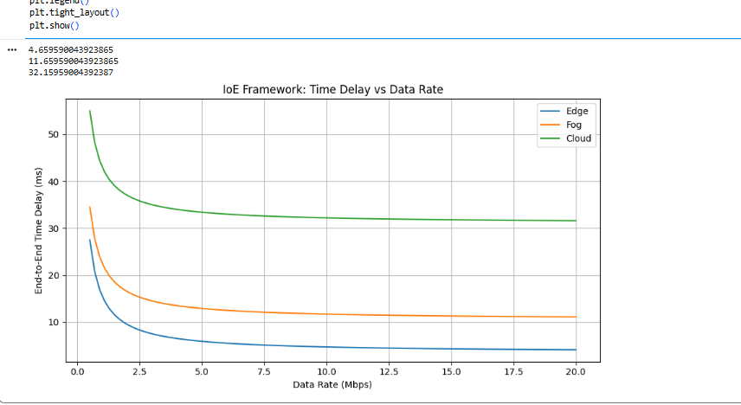

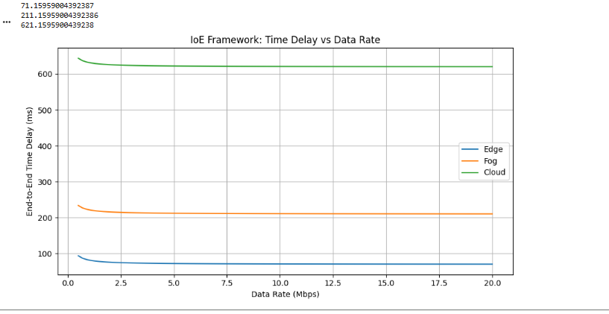
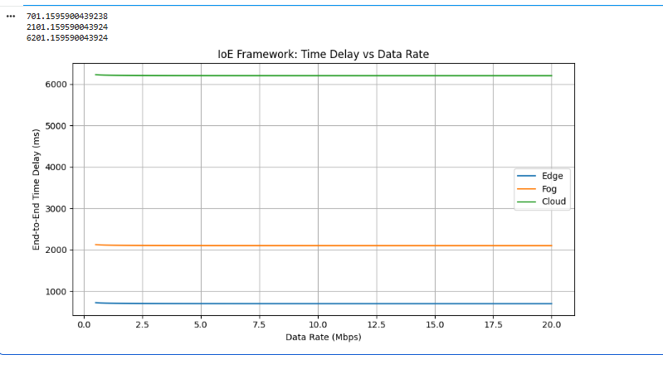
TABLE COLUMN:
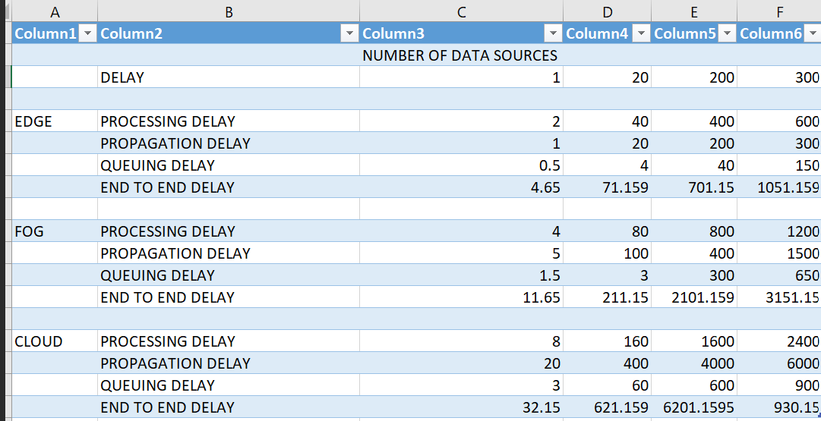

RESULT:
The People-Process-Data-Things (PPDT) IoE framework using the Edge-Fog-Cloud pipeline was simulated and studied. The performance of data processing, latency, and efficiency was evaluated. Thus, the framework supports efficient data management and decision-making in IoE applications.

